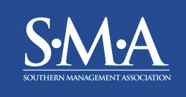
2026 Southern Management Association Annual Meeting AT St. Pete beach, fl
October 27 – October 31, 2026

SPONSORSHIP & EXHIBITION OPPORTUNITIES

The Southern Management Association (SMA) annual meeting will be held October 27 – October 31, 2026, in St. Pete Beach, FL. This premier event offers more than 100 educational sessions, a variety of networking events, professional development opportunities, and student, faculty, and administrator consortia for those in the field of management.

SMA is an affiliate of the Academy of Management (AOM), and the membership of SMA consists of approximately 900 members, representing more than 400 colleges, universities, and business firms from approximately 15 countries.

Thank you in advance for your support of SMA and this important conference. Your generous support allows SMA to deliver one of the best academic conference experiences.

For more information or to register as a Sponsor/Exhibitor, visit:
https://smgmt.org/sponsorship

For questions or to customize a sponsorship opportunity, contact:

SMA Sponsorship Chair:
Frank Butler
sponsorship@southernmanagement.org

or
SMA Executive Director:
Micki Kacmar
Mkacmar@southernmanagement.org
EXCLUSIVE HOST SCHOOL SPONSORSHIP - Contact Frank or Micki

Host School Sponsorship Includes:
- Registration bag insert (provided by sponsor)
- Branded pop-up banner
- Optional exhibitor table
- Information brochure distributed at the event(s) sponsored
- Ad in Whova app
- Recognition at sponsored event(s), online (e.g., SMA website), and on social media

EXCLUSIVE GOLD SPONSORSHIPS - $6,000

Available Sponsorship Opportunities:
- Conference Bags
- Name Badge Holder (SOLD)
- T-Shirts
- Branded Hotel Room Key Cards (SOLD)
- Wednesday Luncheon w/ branded item (e.g., coaster)
- Contact us to create a customized package

Each Gold Sponsorship Includes:
- Registration bag insert (provided by sponsor)
- Branded pop-up banner
- Optional exhibitor table
- Ad in Whova app
- Recognition at sponsored event(s), onscreen (when available), online (e.g., SMA website), and on social media

Inclusions for Specific Sponsorships:
- Wednesday Luncheon w/ branded item also includes branding on admission ticket for the luncheon

SILVER SPONSORSHIPS (non-exclusive) - $4,000

Available Sponsorship Opportunities:
- Early Arrival Reception (Tuesday)
- Sunset Welcome Reception Luau (Wednesday)
- Presidential Reception (Thursday)
- Costumes & Closing Celebration (Friday)
- Golf Tournament Sponsorship
- Contact us to create a customized package

Each Silver Sponsorship Includes:
- Registration bag insert (provided by sponsor)
- Optional exhibitor table
- Ad in Whova app
- Recognition at sponsored event
- Recognition: online, onscreen, and on social media

Inclusions for Specific Sponsorships:
- Golf Tournament includes:
  - Signage at transportation area both at the hotel and returning from the event, golf luncheon, and school logo (sponsor provided) on the awards

BRONZE SPONSORSHIPS (non-exclusive) - $2,000

Available Sponsorship Opportunities:
- Opening Consortium Breakfast
- Early Doctoral Consortium
- Late Doctoral Consortium
- Faculty Consortium
- Academic Leadership Consortium
- Awards Ceremony Sponsorship
- Kacmar Volunteer of the Year Award
- Best Overall Paper
- Best Doctoral Student Paper
- Hospitality University: The TradeWinds Experience
- Applied Enology: A Scholar’s Tasting
- WiFi/AV Sponsorship
- Registration Desk
- Contact us to create a package

Each Package Includes:
- Informational brochures passed out at the event (provided by sponsor) or registration bag insert
- Recognition at sponsored event
- Signage (e.g., school branded poster)
- Recognition: online, onscreen, and on social media

TRACK AWARD SPONSORSHIPS (non-exclusive) - $1,250
Each option covers: Best Paper in Track, Best Doctoral Student Paper in Track, and Best Review in Track.

Available Track Award Sponsorship Opportunities:
- Strategic Management
- Entrepreneurship and Innovation
- Human Resources, Careers, and Development
- Organizational Behavior
- Innovating Teaching and Research Methods
- Ethics and Social Responsibility
- Organization Theory and Special Interest Topics

Each Package Includes:
- Digital photos with sponsor representative(s) and award winners with sponsor institution branding (sponsor provided graphic)
- Recognition at the track awards ceremony
- Recognition: online, onscreen, and in social media

PRE-DOCTORAL PROGRAM SPONSORSHIPS (non-exclusive) – prices vary

Available Sponsorship Opportunities:
- Pre-Doctoral Registration & Orientation - $2,000 (Bronze Level Sponsorship)
- Pre-Doctoral Consortium – $2,000 (Bronze Level Sponsorship)
- Pre-Doctoral Breakfast - $2,000 (Bronze Level Sponsorship)
- Pre-Doctoral Luncheon - $2,000 (Bronze Level Sponsorship)
- Pre-Doctoral Marketing & Outreach Campaign - $1,000
- Pre-Doc University Fair Table (Thursday from 8:00am – 9:30am) - $500

Each Package Includes:
- All sponsors will receive contact information for pre-doctoral participants
- Informational brochures (sponsor provided) passed out at sponsored event
- Short (~5-minute) presentation by a representative of the sponsor school at sponsored event
- Pre-doc University Fair table for donations of $2,000 or more (Thursday from 8:00am – 9:30am)
- Recognition at sponsored event
- Recognition: online, onscreen, and on social media

Inclusions for Specific Sponsorships:
- Pre-Doctoral Registration Also Includes:
  - Signage at the special registration area for pre-doctoral participants
  - Registration bag insert (sponsor provided)

PROFESSIONAL DEVELOPMENT INSTITUTE (non-exclusive) – prices vary

Available Sponsorship Opportunities:
- Podcast - $250 (sponsor can suggest topic)
- Editor Session - $500
- Women’s Session - $500
- Fellows Session - $500
- Contact us to create a customized package

Includes:
- Recognition signage
- On-screen (when available)

NETWORKING OPPORTUNITIES (non-exclusive) – $750

Available Sponsorship Opportunities:
- Coffee Mornings (Thursday & Friday availability)
- Coffee, cold drinks (non-alcoholic), and snacks Afternoons (Thursday & Friday)

Includes:
- Recognition signage
- Logo on coffee cup sleeves

OTHER OPPORTUNITIES (non-exclusive) – prices vary

Available Sponsorship Opportunities:
- Trivia - $1,250
- Improv - $1,250
- Line Dancing - $800
- Track Chair Luncheon - $1,000
- Pumpkin Carving - $1,250
- Pickleball - $1,250
- Memorial Cornhole - $1,250
- Legacy Gift – contact Frank or Micki
- Sponsor a Doctoral Student - $500
- Reception Lighted Logo Ball (see pic below) - $1,250
- Registration bag insert (sponsor supplied) - $50

Includes:
- Recognition signage at event

Inclusions for Specific Sponsorships:
- Pumpkin Carving includes:
  - Sponsor school logo (sponsor provided) on awards
- Pickleball includes:
  - Sponsor school logo (sponsor provided) on awards

EXHIBITORS - $500
Exhibitors receive prime placement at the heart of the conference, guaranteeing unmatched exposure to the full attendee base.

Includes:
- Whova ad and app-based recognition
- 1 exhibitor table with 2 chairs
- 1 complimentary registration
- Inclusion in a “Meet the Exhibitors” flier in registration bag
- Registration bag insert
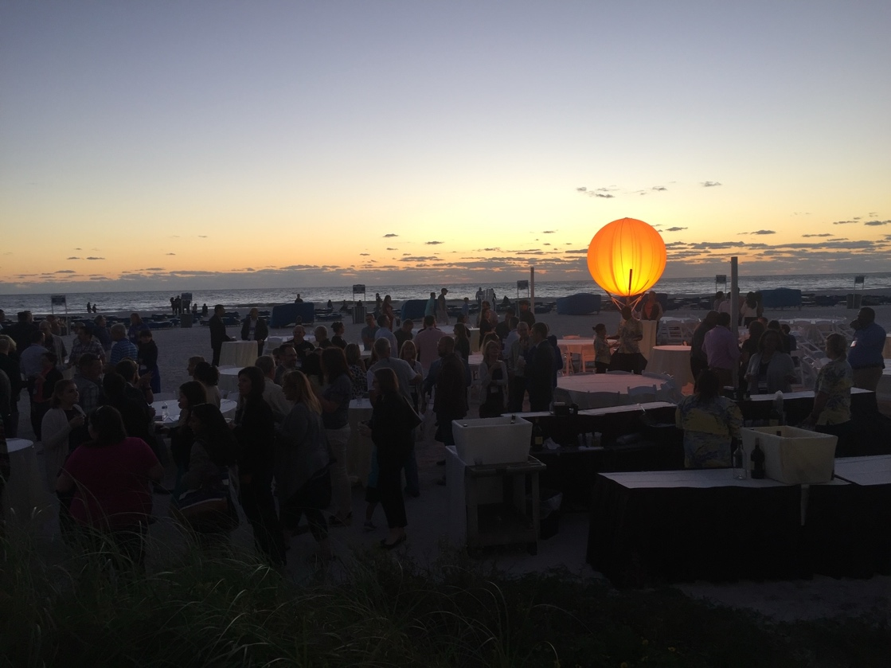
Example of Reception Lighted Logo Ball

** SMA welcomes customized sponsorships **
If you do not see an option you are interested in, or need additional assistance, please contact the SMA Sponsorship Chair at sponsorship@southernmanagement.org

Early Arrival Reception, Sunset Welcome Reception Luau, and Presidential Reception will be held outside. No onscreen recognition at event
The TradeWinds will be providing us with an exclusive, behind the scenes tour into their operations. They are unique in how they manage their people and operations. This will be an incredible experience for all Management scholars.
Pre-Doctoral Marketing & Outreach will provide a sponsored flier shared with all MBA programs of schools who have participate in SMA. School sponsorship will be recognized on the flier.
Pre-Doc University Fair will be a special recruiting event, an academic trick or treat, for doctoral programs with the pre-doctoral consortium participants required to attend. 8 tables sold is required for the event to be held.
Excluding the Pre-Doc University Fair Table and Pre-Doctoral Marketing & Outreach Campaign sponsorship.
These will also be present for the Tuesday, Wednesday, and Thursday receptions and Friday memorial event.

